CENWP-OD-J January 19, 2024

MEMORANDUM FOR THE RECORD

SUBJECT: 24JDA02 MFR JDA-S Temperatures updates

Background:

In 2016, John Day, The Dalles, and Bonneville Dam began monitoring and reporting fish ladder temperatures after high river temperatures during the 2015 migration year contributed to low sockeye salmon passage and survival. Elevated water temperature differentials between the entrance and exit, in adult fish ladders are associated with altering salmon behavior and potentially slowing adult salmon migration (Caudill et al. 2006; USACE 2004).

In 2018 and 2019, in response to regional concern over entrance-exit temperature differentials throughout the Columbia River System a temperature depth profile study was conducted on the lower Columbia River projects to monitor the vertical thermal profile of the forebays next to fish ladder exits and determine if cooler water existed for cooling of the fish ladders (Lundell et al 2019). The study concluded that although the forebays of The Dalles and Bonneville projects remained well-mixed throughout the summer months, John Day exhibited periods of significant temperature differentials coupled with a stratified reservoir that suggests a potential for fish ladder cooling near the fishway exit. In the 2020 Columbia River System Biological Assessment, the Corps proposed to:

- Continue monitoring and reporting of all mainstem fish ladder temperatures and identify ladders that have substantial temperatures that have differentials >1.0° C.
- Where beneficial and feasible, develop and implement operational or structural solutions to address maximum temperatures and temperature differentials in adult fish ladders at mainstem Lower Snake and Columbia River Dams identified as having problems (2020 CRS BA).

This memo directly addresses the Proposed Action by evaluating 2019, 2022, and 2023 ladder temperature differentials in the South fish ladder at John Day Dam (JDA) and evaluating an operational alternative (extended shad mode) tested in 2022 to try to reduce entrance-exit thermal gradients during adult passage season.

There were periods of time in the summers of 2019, 2022, and 2023 when the water entering the fishway exit from the forebay was several degrees warmer than the water at the fishway entrance (tailrace), exceeding the 1°C target threshold (Figure 1). During those same periods of time in the summers of 2019, 2022, and 2023, deeper water in the forebay at JDA-SS-2 was as much as 5.2°C cooler than the water at the surface (Figure 2).
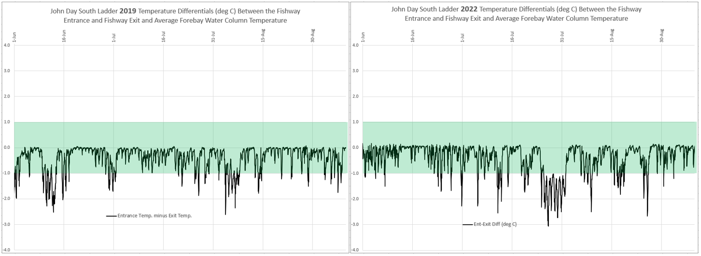
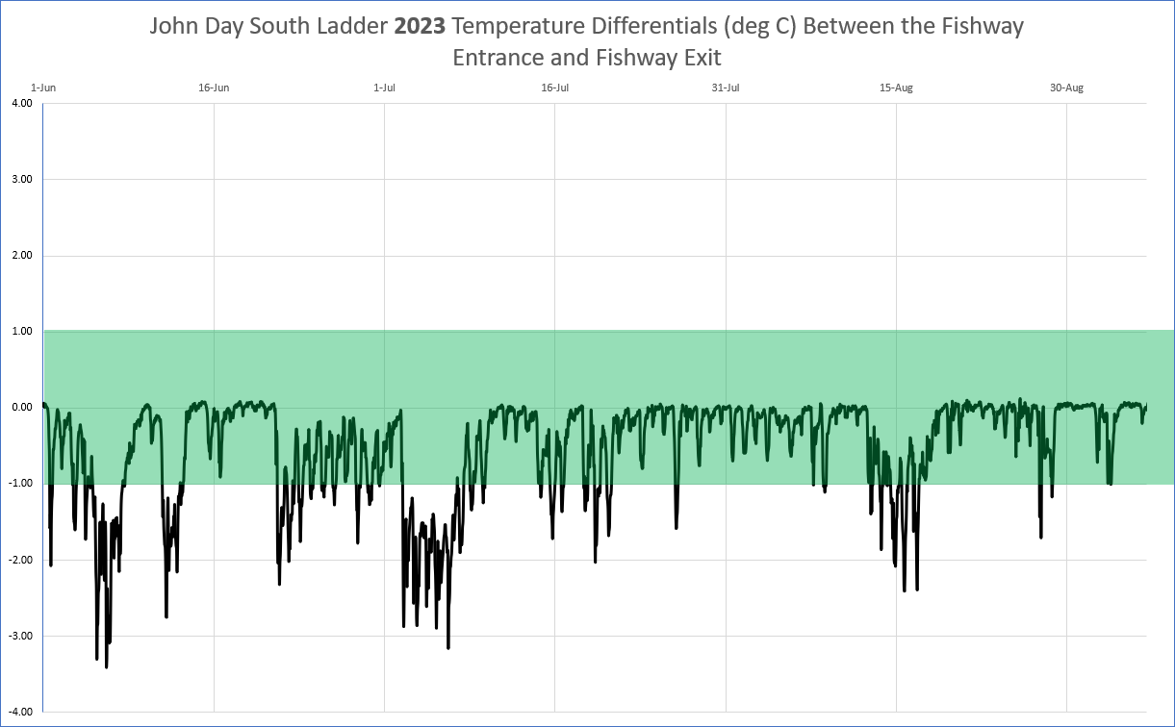

Figure 1: Temperature differentials between the entrance and exits at John Day Dam SFL from June 1 to September 15 in 2019, 2022 and 2023.
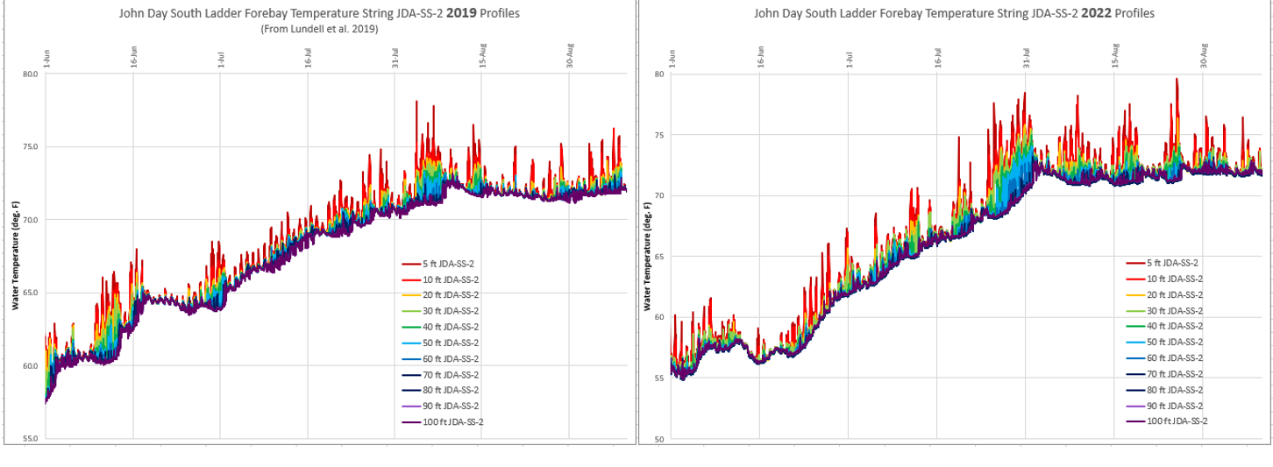
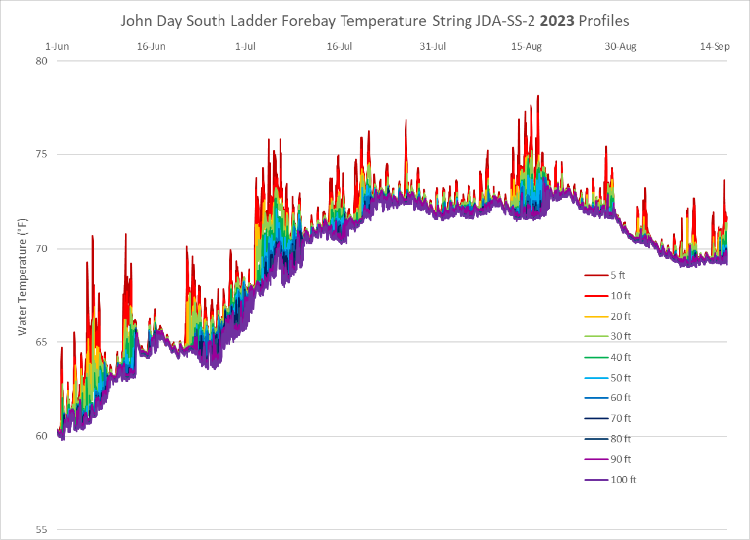

Figure 2: JDA-SS-2 temperatures from June 1 to September 15 in 2019, 2022 and 2023.
According to NMFS (2016), the upper incipient lethal temperatures for adult salmonids range from 70°F to 72°F. Sustained exposure to temperatures above 68°F can slow adult sockeye migration, warmer temperatures can stop adult sockeye migration completely with fish seeking shelter in tributaries, cold water refuges, or the estuary. In 2019 and 2022, most of the sockeye run had past John Day Dam before the river reached 68°F. However, 2023 saw significantly more overlap (Figure 3).
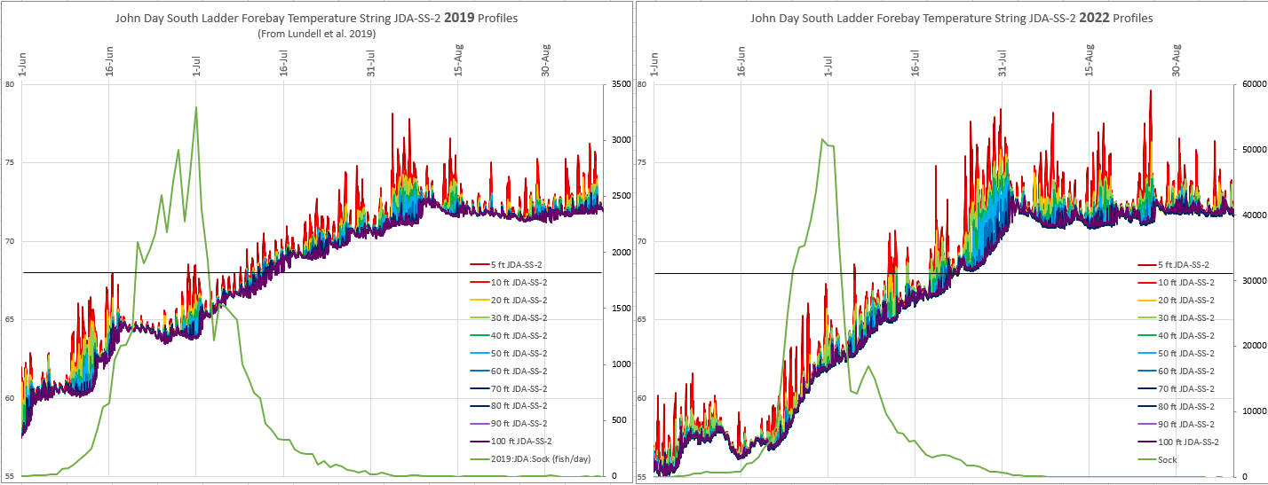

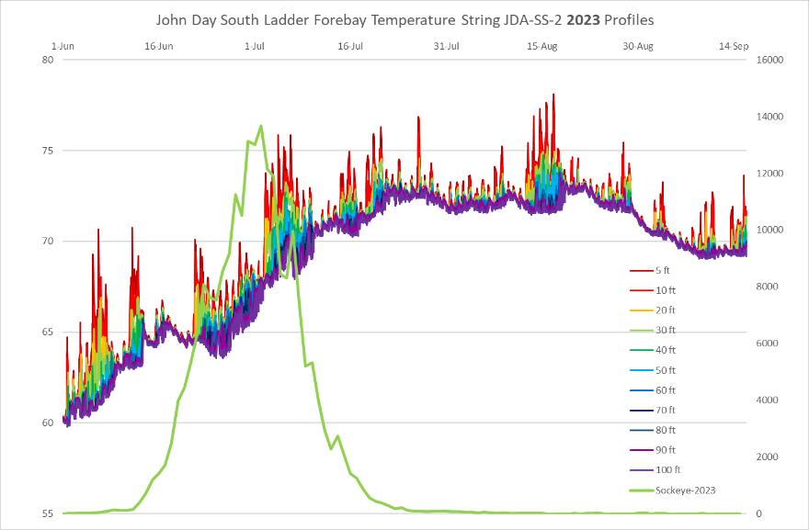

Figure 3: Forebay temperatures (deg. F; left axis) and sockeye passage (fish/day; right axis) for the south fish ladder at John Day Dam in 2019, 2022, and 2023.
At temperature differentials of greater than 1°C, Chinook and steelhead have a higher likelihood of entering the ladder multiple times followed by exits back into the tailrace. This movement in the ladder can significantly delay migration, increase thermal exposure, consume energy, and decrease migration success (Keefer and Caudill 2015). Temperature differentials in 2019, 2022, and 2023 are shown in Figure 4 with 2023 having the highest occurrence exceeding 1°C.

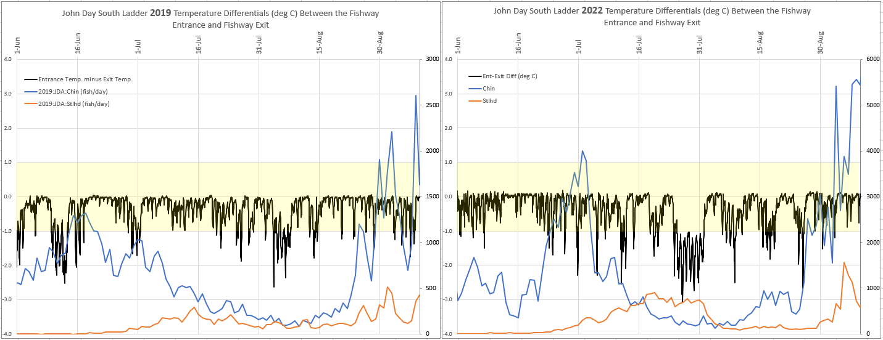
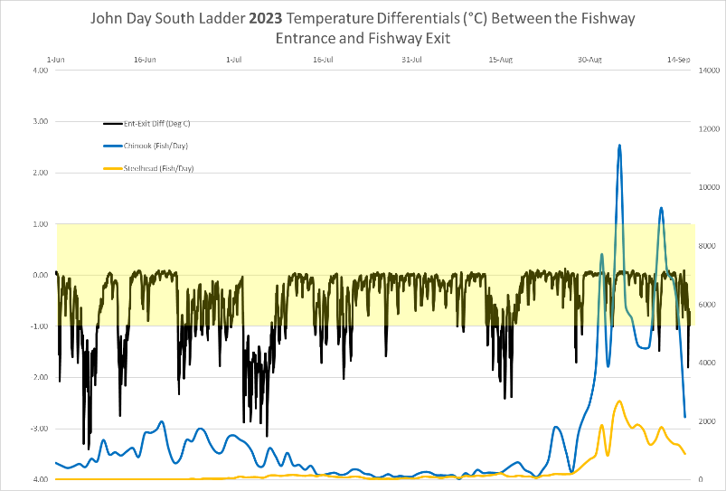
Figure 4: Chinook (blue) and Steelhead (orange) passage (fish/day) for the south fish ladder at John Day Dam in 2019, 2022 and 2023.
Method:
Temperature data has been collected from the JDA South Fish Ladder (SFL) entrance and exit sections since 2011 to monitor potential exit/entrance differentials. From 2011 - 2021 the readings were taken from the same locations (See figure 5) and reported to FPOM annually. In 2022 (prior to adult passage season) JDA personnel installed 5-additional temperature probe locations (See figure 5) including a temperature string in the forebay just upstream of the ladder exit (following the methods set forth in Lundell et al. 2019). These additional probe locations were used again in 2023. 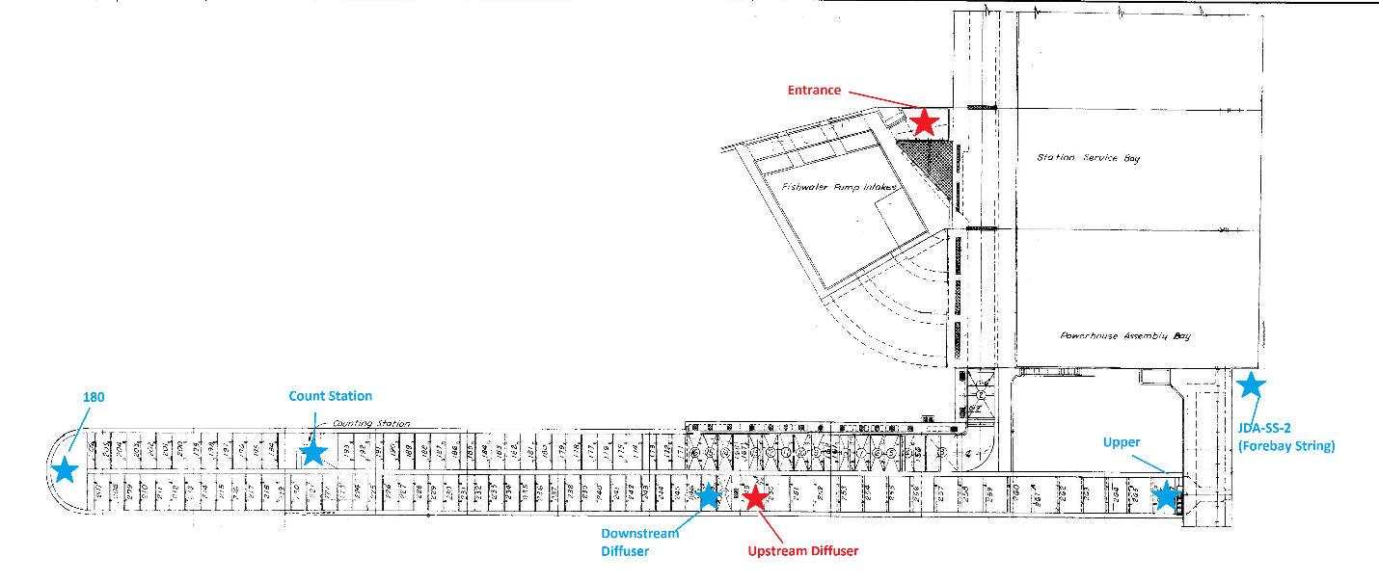Figure 5: Map of the JDA SFL and the temperature probe locations within the ladder. Red stars indicate preexisting temperature probe locations (installed in 2011). The blue stars represent new temperature probes installed prior to the 2022 adult passage season. The red star labeled upstream diffuser is what has been historically referred to as the south fish ladder exit.
For most locations, JDA uses Onset HOBO temperature loggers (Model: U22-001) deployed down 2” PVC pipes mounted to the ladder wall (the pipes are drilled to allow water circulation). The loggers collect data approximately 1-foot from the ladder floor. The count station location uses a Hobo tidbit temperature logger affixed between the picketed leads. Unfortunately, the temperatures at this location cannot be read out until the ladder is dewatered (there are currently plans to install a PVC pipe at this location during the 2022/2023 winter maintenance window to allow in season offloads - Update: the count station PVC pipe was successfully installed during the 2022/2023 winter maintenance window). The forebay temperature string (referred to as JDA-SS-2) utilizes U22-001 temperature loggers at 11-depths (5, 10, 20, 30, 40, 50, 60, 70, 80, 90, and 100-feet with a base forebay elevation of 262.9-feet).
Temperature loggers are set to record hourly, and data is typically offloaded weekly. Unfortunately, there were times when weekly readouts weren’t feasible (short staffed, heavy workloads, malfunctioning equipment, etc.) and blocks of data were lost (See Table 1). Comparing data from these blocks isn’t feasible. Therefore, most of the data is displayed as 10-year averages to help offset the lost data.
Table 1: The timeframes when JDA has temperature data available for the SFL and USGS has temperatures available for the forebay (2014 – 2023).

The SFL exit is typically warmer than the entrance (See Figure 6) and the differentials tend to fluctuate throughout the day (see Figure 7).
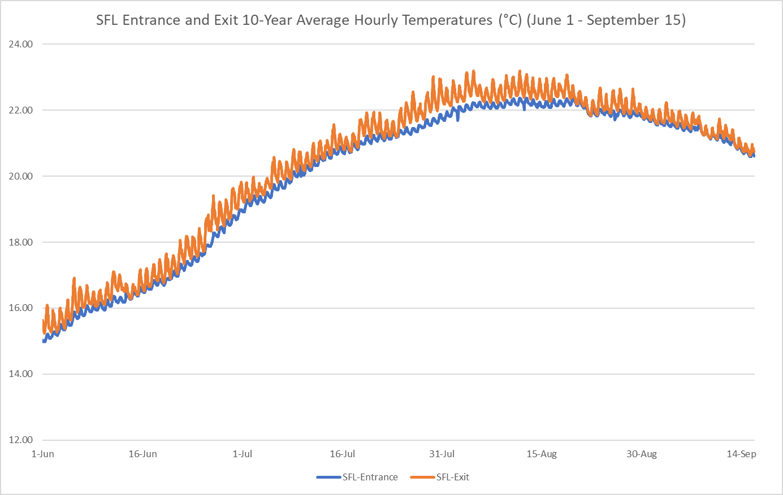
Figure 6: The SFL entrance-exit hourly temperatures (°C) shown as a 10-year average (2014-2023) June 1st – September 30th.
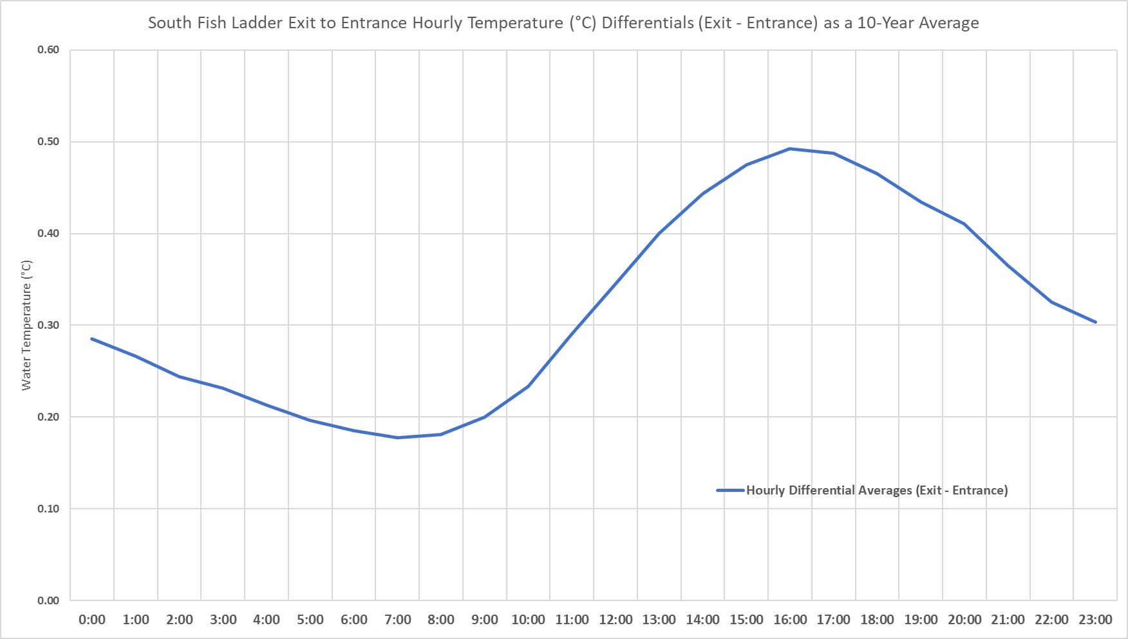
Figure 7: Graph illustrating temperature differentials between the SFL exit and the SFL entrance at different times of the day (how many degrees °C the exit is warmer than the entrance). The values are shown as 10-year average temperatures (2014 – 2023) at specific hourly intervals from June 1st – September 15th. Years 2018 and 2021 were omitted due to incomplete data sets.
The average 10-year differential between the SFL exit and entrance (when the exit was ≥70°F) was 0.70°F (See Table 2). When the temperature differential is 1°C salmonid passage is negatively impacted. Over the course of 10-years, the differential was ≥1°C (1.8°F) 13.3% of the time (when the exit was ≥70°F). The highest percentage observed was 2017 (20.92%) and the lowest was 2014 (3.51%).

Table 2: Table representing the total number of hours the JDA SFL exit was ≥ 70°F and of those hours, the number of hours the SFL exit was ≥ 1°C warmer than the SFL entrance. The percentage represents the time when the SFL exit was ≥ 1°C warmer than the entrance (when the SFL exit was ≥70°F). Tables show a 10-year span and are broken up by; June - July, August – September, and both combined (June – September). There are 2,928 hours between June 1st and September 30th.
Fish run timing varies year to year and species to species at JDA (See Figure 8). When comparing the 10-year average water temperature to the 10-year average salmonid passage (at JDA) the following overlaps are observed. Steelhead have the highest interaction with warmer ladder temperatures at JDA with 45.0% (updated with 2023 passage: 47.0%) of the total steelhead run passing when ladder temperatures are ≥70 F°. Sockeye passage has the least overlap with 3.0% (updated with 2023 passage: 3.8%) passing at temperatures of ≥70 F°.
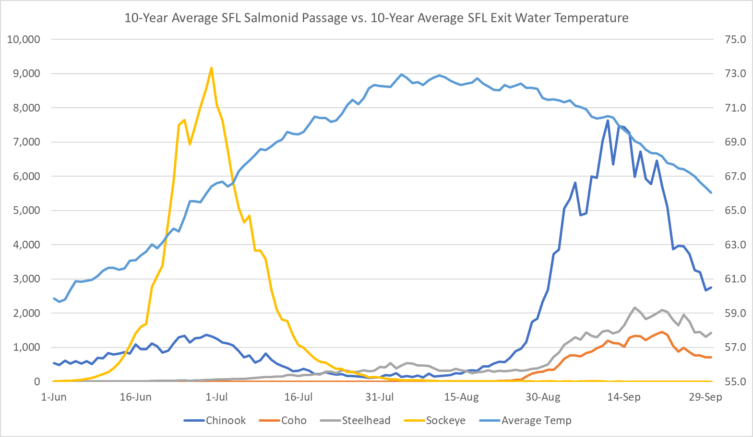
Figure 8: The 10-year average (2014 - 2023) for salmonid passage at the South Fish Ladder of John Day Dam. The secondary axis is the average daily water temperature at the JDA south fish ladder exit (°F).

The Following Study Was NOT Repeated for 2023 and NO Updates Were Made to This Section:
Post 2022 block-study
The block-study (MOC: 22JDA07) occurred over a 16-day period (August 2nd – August 17th, 2022) with two-day replicates of “shad mode’ and “salmon mode” operations. Temperature differential between the exit and the entrance (Figure 9) were slightly cooler (0.84°F) during the shad mode than during the salmon mode (1.05°F). Ladder exit temperature fluctuated more than the entrance temperatures (Figure 10) during the block study. The average exit temperatures during the block study were 72.27°F during shad mode and 72.53°F during salmon mode and entrance temperatures were slightly higher in salmon mode (71.48°F) than during shad mode (71.43°F). Lamprey passage (Figure 11) during the shad and salmon operation was higher than the ten-year average.

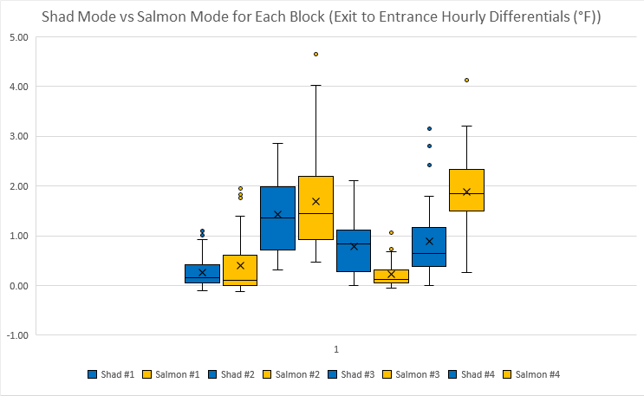
Figure 9: Graph illustrating the exit to entrance differentials during each block of the study. Blue boxes indicate shad mode, while gold boxes indicate salmon mode.

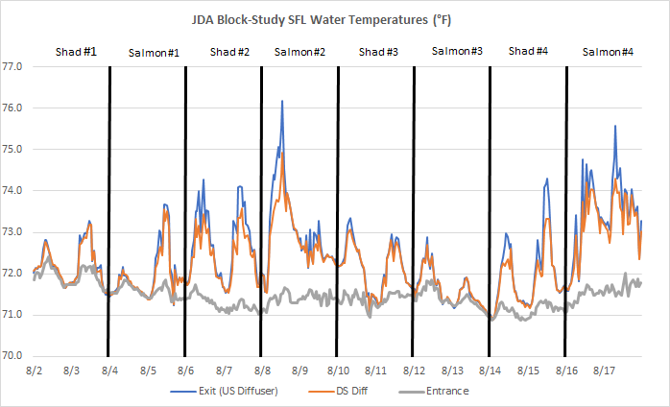
Figure 10: Graph illustrating the recorded hourly temperatures during the block study. The blue line indicates the location just upstream of the diffuser (where the additional water is added in ‘shad mode’), the red line temperatures are taken just downstream of the diffuser, and the gray line is the entrance water temperature.
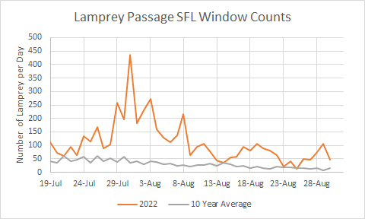
Figure 11: This graph shows 2022 versus the 10 Year Average (2013-2021) of lamprey passage at the South Fish Ladder for two weeks before the start of the block study and two weeks after the block study (8/2-8/16). The number of lampreys per day are from the window counts at the count station. Lamprey passage at the SFL was well above the ten-year average and peaked on July 31st at 436 fish. The CRITFC SFL lamprey trap had their highest catch this year of 1,349 fish.

Ladder Operations:
The John Day Dam South fish ladder uses three Francis turbine pumps to supply attraction water for the SFL (See Figure 12). The turbine pumps are supplied by a 5’ penstock located at 200’ msl in the forebay of the dam approximately 90-feet north of the fish ladder exit. The turbine drives a gear box that pumps water from a stilling basin on the downstream side of the dam at 90’ msl. Normal forebay and tailrace operations at JDA are 262.5’ – 266.5’ msl and 159’ – 162.5’. This water is used for attraction flows at the SFL entrances, collection channel flow between the South and North ends of the powerhouse and diffusion chambers in the lower overflow weirs above the transition pool at the base of ladder.

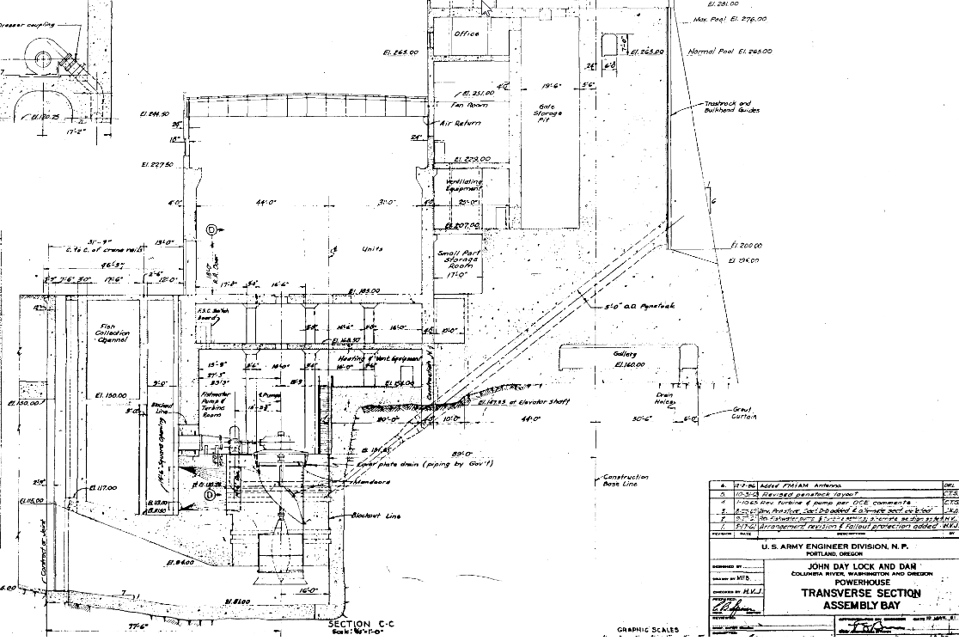
Figure 12: Transverse cross section of assembly bay showing SFL fish turbine penstock intake and discharge and pump assembly intake and discharge.
Additionally, water is added to the SFL from diffuser #5 above weir 248 which is the last overflow weir before the start of the exit control section (See Figure 13). The diffuser is fed from two 24” supply lines from a forebay intake at 238’ msl. Actuated butterfly valves automatically adjust flow to the diffuser keeping 1’- 1.3’ of water over the overflow weirs depending on the ladder setting. The level is monitored and adjusted from readings taken between weirs 193 and 194 at the SFL count station. Water flows from diffuser #5 range from 5.5 – 88.1 cfs and vary based on operational setting and forebay elevations (See Table 3). Between June 10th and September 9th, 2019, water temperatures at the diffuser were on average ~0.5°F cooler than surface water temperatures (measured at ~5’ of depth) (Lundell et al. 2019).

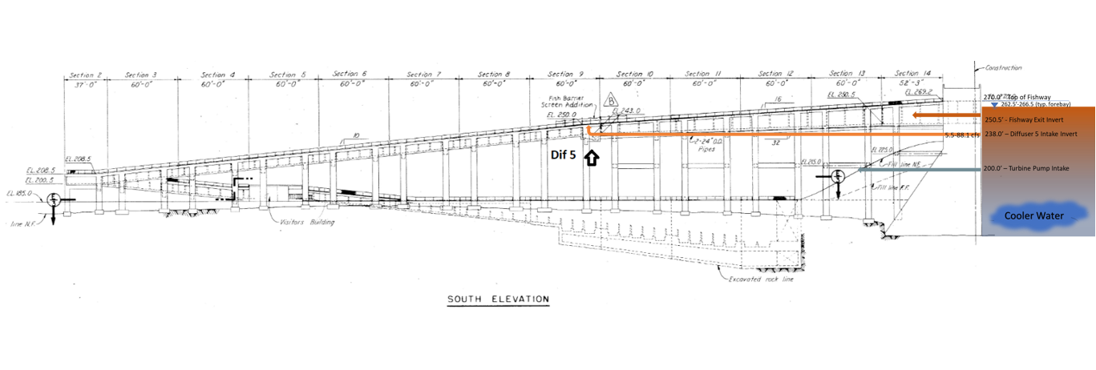
Figure 13: General layout of elevation sections including views of Diffuser #5 and 24” supply lines from forebay intake at 238’msl.
Table 3: Ladder flows based on forebay elevation and corresponding sill setting and diffuser flow.
Ladder flow starts in the forebay as water passes through the exit into the upper control section of the ladder. The control section is of a vertical slot weir configuration with a 1:32 slope. Adjustable actuated sill gates on weirs 256 – 267 modulate gravity flow from the forebay based on water elevation (See Figure 14).
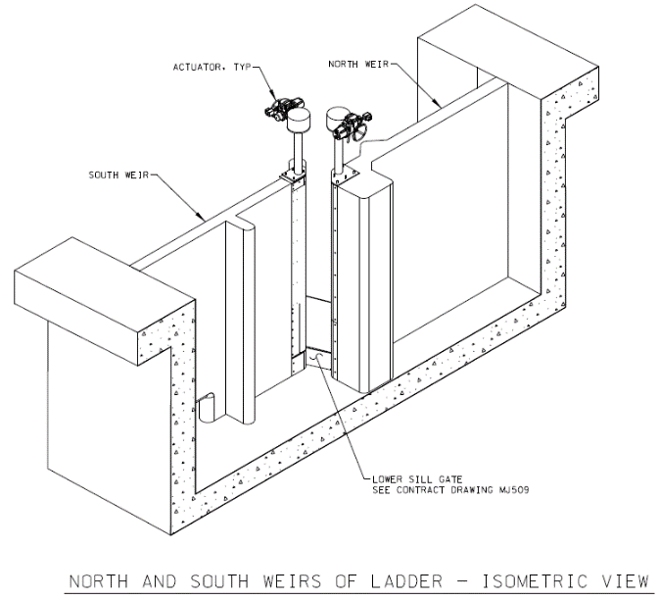
Figure 14: Vertical slot weir with actuated sill gates and orifice in the SFL exit control section.
Operational changes are made to ladder flows during the annual American Shad (shad) run at JDA. Shad have difficulty ascending the ladders through submerged orifices. Once shad passage at Bonneville Dam exceeds 5,000 per day, fish ladders at JDA increase the ladder flow through diffuser #5 at the SFL to 1.3’ over the overflow weirs to aid shad in their passage. The 10-year average of shad operation at JDA is 54 days and ranged from 22 May to 4 August (See Table 4).
Table 4: Operating range of fish ladders at JDA for American Shad at 1.3’ over weirs.

Conclusion:
Between June and September, the JDA SFL experiences frequent warm water periods (≥70°F at the SFL exit). During this time the SFL exit is typically warmer than the entrance and differentials >6.5°F have been observed. Figure 15 compares the entrance-exit temperature differentials observed in 2019 and 2022 to temperature differentials between the entrance and deeper parts of the forebay, suggesting water from different depths in the forebay could help to temper variations in entrance-exit differentials when the forebay is stratified.
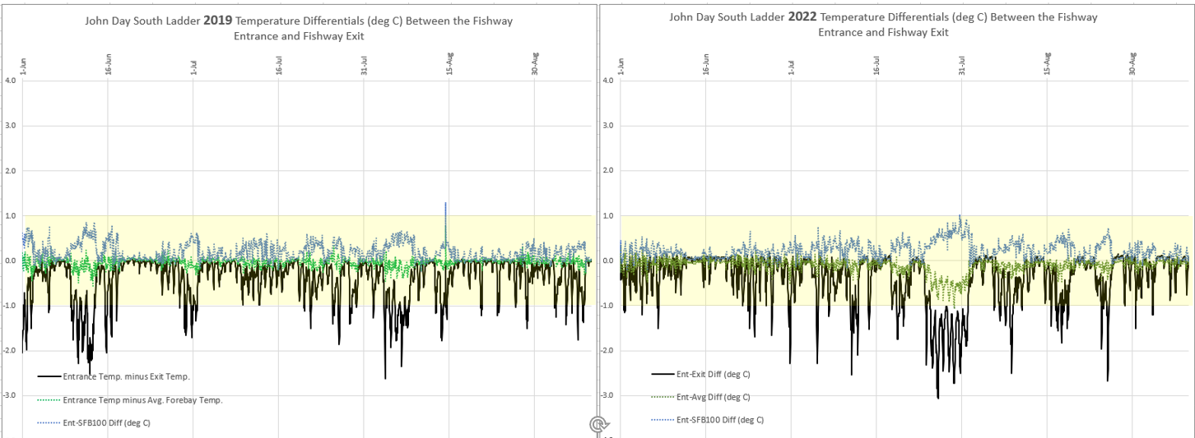
Figure 15 : Comparison of entrance: exit, entrance: forebay@100', and entrance: forebay avg. temperature differentials for JDA south ladder in 2019 and 2022. Blue dotted lines: If all the water entering the JDA South fish exit came from a depth of 100 feet in 2019 and 2022, the exit temperature may have been consistently cooler than the entrance temperature. Green dotted lines: If all the water entering the JDA South fish exit came from a depth of 40-50 feet deep, or the forebay water column at the JDA South fish exit was well-mixed (homogenous temperature top-to-bottom), in 2019 and 2022, we may have seen fewer occurrences of differentials >1 degree C.
Adult salmonids migrating above JDA typically experience different ladder operations between June and July than those migrating between August and September. Within warm water periods, ladder temperature differentials ≥1°C are typically observed more frequently between August and September (exceptions being 2015 and 2021). The exact impacts this has on SFL salmonid passage are unknown.
Temperature differentials between the exit and entrance of the South Fish Ladder at John Day Dam have been documented in 2018 and 2019. In 2022, JDA personnel deployed a forebay temperature string at JDA-SS-2 (same location as the 2018 and 2019 Lundell study) and deployed additional temperature probes within the SFL. Temperature differentials again were observed exceeding 1.0°C between the exit and entrance in 2022. The forebay string also indicated stratification near the ladder exit with cooler water below the 70’ depth.

Recommendations:
The USACE recommends proceeding with the USACE design process and initiating an Engineering Documentation Report (EDR) to evaluate alternatives for cooling the SFL exit. Some key questions heading into the EDR development:
- How much cool water exists at depth in the JDA forebay to help cool the ladder exit, and what is the temporal availability relative to adult run timing?
- What is the expected year-to-year variability of the success of a ladder cooling structure (i.e. in the critical hot and/or dry years)?
The available data does not suggest the thermal gradients and maximum temperatures observed in the SFL at JDA are resulting in a passage problem. While we recognize the temperature differentials between the entrance and the exit, we do recommend additional analysis of fish passage at JDA while alternatives are being evaluated during the EDR process.
References:
Caudill, C. C., T. S. Clabough, G. P. Naughton, C. A. Peery, and B. J. Burke. 2006. Water temperatures in adult fishways at mainstem dams of the Snake and Columbia rivers biological effects. Technical Report 2006-3. U.S. Army Corps of Engineers, Walla Walla District, Walla Walla, WA.

Fielding, S., E. Grosvenor, M. Lotspeich, L. Ricketts. 2021. 2021 Annual fishways status report. U.S. Army Corps of Engineers, Portland District.

Hydraulic evaluation of lower Columbia River adult bypass systems (HELCRABS). John Day south fish ladder hydraulic/operational evaluation. 2015. U.S. Army Corps of Engineers, Portland District.

Lundell et al. 2019. Lower Columbia River dam forebays temperature depth profile study for 2019. U.S. Army Corps of Engineers, Portland District.
NMFS (National Marine Fisheries Service). 2016. 2015 Adult Sockeye Salmon Passage Report.

